***Question # 01:***

Write a program in C to print a string in reverse using a pointer.

***Exercise # 02:***

Write a program in C to find the largest element using Dynamic Memory Allocation.

***Exercise # 03:***

Write a program in C to print all permutations of a given string using pointers.

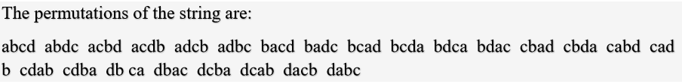

***Question # 04:***

Get an ‘n’ sized array from user, sort it and then prompt user to provide integer and place it in the array at its respective index via pointer.

***Question # 05:***

Governments and companies worldwide are becoming increasingly concerned with carbon footprints from buildings burning various types of fuels for heat, vehicles burning fuels for power, and the like. Many scientists blame these greenhouse gases for the phenomenon called global warming. Your task is to help scientist to calculate carbon footprints of a building, a car and a bicycle, respectively. Create three function, each function should input appropriate data from the user, then calculate and display the carbon footprint. Each function should receive no parameters and return void. Write a program that prompts the user to enter the type of carbon footprint to calculate, then calls the corresponding function in main (). For each type of carbon footprint, display some identifying information and the object’s carbon footprint. Scientist have gave you some information that may help you.

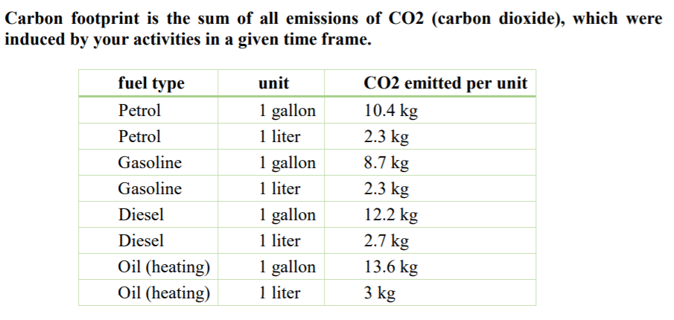

**Example:** If your car consumes 7.5 liter diesel per 100 km, then a drive of 300 km distance consumes 3 x 7.5 = 22.5 liter diesel, which adds 22.5 x 2.7 kg = 60.75 kg CO2 to your personal carbon footprint.

***Question # 06:***

Write a single function that receives an array of 5 integers and returns the sum, average and standard deviation of these numbers without using return statement. Call this function from main( ) and print the results in main( ).

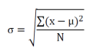

***Question # 07:***

Write a program to declare a square matrix A[ ] [ ] using dynamic memory allocation of order (M x M) where ‘M’ is the number of rows and the number of columns such that M must be greater than 2 and less than 20. Allow the user to input integers into this matrix. Display appropriate error message for an invalid input. Perform the following tasks:

(a) Display the input matrix.

(b) Create a mirror image matrix.

(c) Display the mirror image matrix.

Test your program with the sample data and some random data:

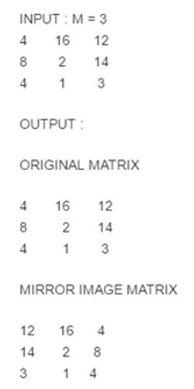

***Question # 08:***

Write a program to print the following pattern using pointer.



***Question # 09:***

Write a program t allocate the memory on runtime and sort a set of names.

char *name[] ={"Bilal","Areeba","Raheem","Danish","Zainab","Fatima"}

***Question # 10:***

Write a program that prompts the users to enter 12 numbers. This program reads the numbers into an array. Make another array that will store the average of numbers.

The two arrays will be passed to a function for and the average will be calculated by

1. Take First Four Numbers at index calculate their average and store at first index in Average Array.
2. Next time skip the first index number and average the next 4 Index Numbers and store at second index in Average Array.
3. And this procedure will continue, until Average for all windows will be stored in Average Array.

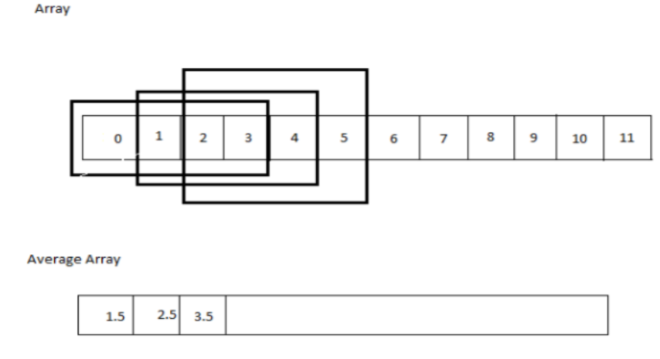

Home Assignment:

***Question # 11:***

Write a C language program. The program intends to include the following modules. The solution must be provided using only the mentioned functions.No global variables shall be declared. Use appropriate data types, return types and function arguments.

1. Module Name: “ProductsList()”.This module holds and displays a list of hard coded products along with their prices.   
   The list is as follows:   
    Products: Price  
    Milk 80.23/-   
    Loaf 347.52/-   
    Beef 50.36/-   
    Eggs 50/-   
    Fish 85/-   
    Surf 56.58/-   
    Cake 70.236/-   
    Soap 103.63/-   
    Lamb 50.23/-   
    Corn 70.236/-
2. Module Name: “AddProduct()”. This function takes the products’ names as input from the customer and adds them to an array named “shoppingCart”.The shoppingCart must contain five or less products. If more than five products are entered, an error message must be displayed. If the product does not exist in the list, the user must be prompted to enter the valid product.
3. Module Name: “CalculateBill()”. This function calculates the bill by matching the products in “shoppingCart” and the hard coded list in order to obtain the prices. If the “shoppingCart” contains two or more similar products (e.g. two Soaps) then the customer is only charged for one such product as a discount.
4. Module Name: “DisplayProductsBill()”.This function displays the added products(i.e. the “shoppingCart”) along with the final bill.
5. Module Name: “main()”.It must only call the ProductsList() module to begin the execution.

***Question #7***

Convert numerical date into following format using pointers:

19 11 2018 => Monday, November 19, 2018